Project 1

Shaotian Wu, Chenting Zhang

1. INTRODUCTION

In this report, we will discuss about some properties of the Gaussian Distribution and system models with Gaussian Noise. The whole passage is partitioned into three parts, introduction, problem formulation and solution, in which we would briefly formulate the problems and provide feasible solutions using mathematical tools. Lastly, we would make a conclusion of this report and highlight the most important parts of the solution and briefly discuss some implications.

1. PROBLEM FORMULATION AND SOLUTION
   1. Part 1

Task 1: There are three sequences of different lengths which are generated from Gaussian Distribution process, we need to calculate the mean and the variance of the distribution. And analyze how the length of sequence impact on the approximation of original distribution from plotting the empirical distributions.

Solution:

For discrete random variable, we could calculate the mean of the variance of each sequence by using the formula as follows:

$$m_{x}=E\left(x\right)=\frac{1}{n}\sum_{i=1}^{n}{x_{i}}$$

$${var}_{x}=\frac{1}{n}\sum_{i=1}^{n}{ {\left(x_{i}-m_{x}\right)}^{2}}$$

Thus, the images of each empirical distribution sequence could be drawn as follows:



Image 1: empirical pdfs of three sequenses

We could tell from Image 1 that when $N_{i}$ increases, the empirical distribution is much closer to the real Gaussian distribution.

Task 2: There are two sets of two-dimensional matrices. Firstly it is needed to write down the general expression for the joint Gaussian distribution $f_{XY}(x,y)$, and then plot their three-dimensional empirical pdfs. Lastly, analyze the relationship between the shape of pdf and the correlation coefficient.

Solution:

For joint Gaussian distribution $f_{XY}(x,y)$, the two-dimensional probability density function of a vector [x, y] is written as follows:

$$\begin{aligned}f\left(x,y\right)=\frac{1}{2πσ_{1}σ_{2}\sqrt{1-ρ^{2}}}\exp\left\{-\frac{1}{2\left(1-ρ^{2}\right)}\left[{\left(\frac{x-u_{1}}{σ_{1}}\right)}^{2}-2r+{\left(\frac{y-u_{2}}{σ_{2}}\right)}^{2}\right]\right\}\#\left( = 1 \backslash * Arabic 1\right)\end{aligned}$$

Where $ρ$ is the correlation between X and Y and where $σ_{1}>0$ and $σ_{2}>0$

$$ρ=\frac{cov(X,Y)}{σ_{x}σ_{y}}$$

The correlation coefficient is a number calculated from given data that measures the strength of the linear relationship between two variables: x and y. The sign of the correlation coefficient indicates the direction of the linear relationship between x and y. When $ρ$ is near 1 or −1, the linear relationship is strong; when it is near 0, the linear relationship is weak.

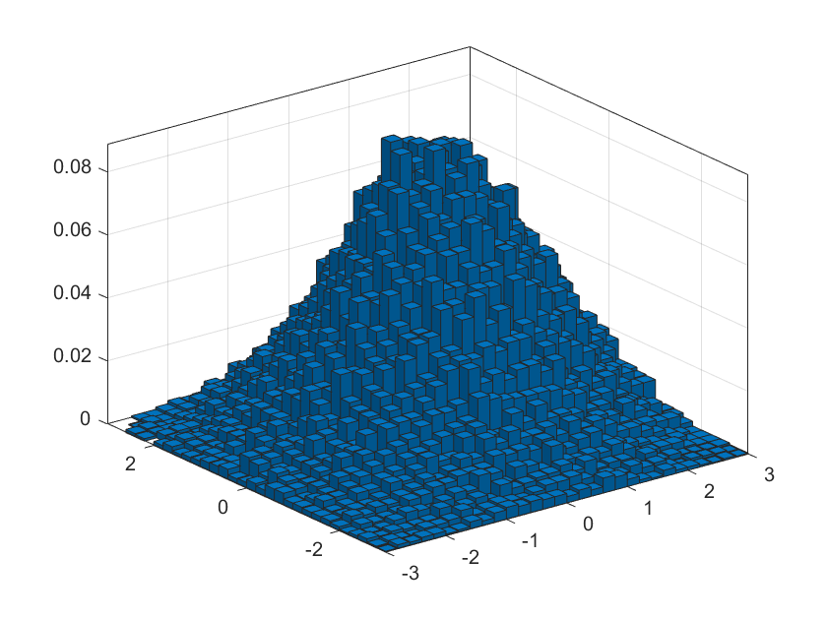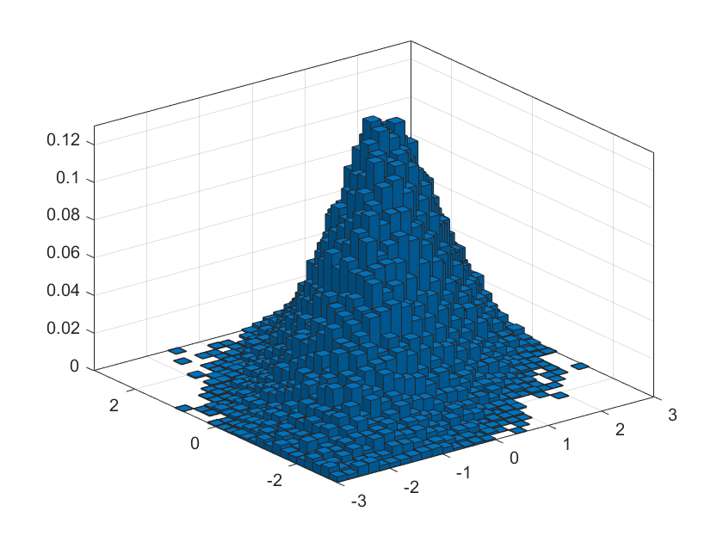

Image 2: empirical pdfs of two sets of two-dimensional matrices

We know that the correlation coefficient $ρ$ between X and Y takes one of the values {0.25, 0.75}, so we could draw from Image 2 that linear relationship between X and Y in sequence2 is strong, so its correlation coefficient $ρ$ is 0.75. Likewise, linear relationship between X and Y in sequence1 is week, so its correlation coefficient $ρ$ is 0.25. Apart from that, A negative correlation occurs when the correlation coefficient is less than 0. This is an indication that both variables move in the opposite direction. For example, if one variable increases, the other variable decreases and vice versa.

Task 3: Show the mathematical derivation and expression of pdfs of conditional distribution $f\left(Z=x | Y=y\right)$, X+Y and X-Y at a given correlation coefficient.

Solution:

Formula (1) has given the pdf of joint distribution function of two-dimensional Gaussian variables. And the pdf of one-dimensional Gaussian variable is written as follows:

$$\begin{aligned}f_{X}\left(x\right)=\frac{1}{\sqrt{2πσ^{2}}}\exp\left\{-\frac{{\left(x-u_{1}\right)}^{2}}{2σ^{2}}\right\}\#\left( = 2 \backslash * Arabic 2\right)\end{aligned}$$

$$f_{Y}\left(y\right)=\frac{1}{\sqrt{2πσ^{2}}}exp⁡\{-\frac{{(y-u_{2})}^{2}}{2σ^{2}}\}$$

Then due to the definition of conditional distribution, we could do as follows:

$$f\left(Z=x | Y=y\right)=\frac{f_{XY}\left(x,y\right)}{f_{Y}\left(y\right)}=\frac{\frac{1}{2πσ^{2}\sqrt{1-ρ^{2}}}exp⁡\{-\frac{1}{2\left(1-ρ^{2}\right)}[{\left(\frac{x-u_{1}}{σ}\right)}^{2}-2r+{\left(\frac{y-u_{2}}{σ}\right)}^{2}]\}}{\frac{1}{\sqrt{2πσ^{2}}}exp⁡\{-\frac{{(y-u_{2})}^{2}}{2σ^{2}}\}}=\frac{1}{\sqrt{2πσ^{2}(1-ρ^{2})}}exp⁡\{-\frac{1}{2\left(1-ρ^{2}\right)}[{\left(\frac{x-u_{1}}{σ}\right)}^{2}-2r+ρ^{2}{(\frac{y-u_{2}}{σ})}^{2}]\}$$

Since Gaussian Process is a linear operator, $Z=X+Y$ and $Z=X-Y$ also follow the Gaussian distribution. We could obtain the mean and variance of these two random variables:

$X\sim N(u_{1},σ^{2})$, $Y\sim N\left(u_{2},σ^{2}\right)$, $X+Y\sim N(u_{1}+u_{2},2σ^{2})$, $X-Y\sim N(u_{1}-u_{2},2σ^{2})$

Then plug in the mean and variance into formula(2) respectively, we could obtain the pdfs of these two random variables.

$$f\left(Z | z=x+y\right)=\frac{1}{\sqrt{4πσ^{2}}}exp⁡\{-\frac{{[z-(u_{1}+u_{2})]}^{2}}{4σ^{2}}\}$$

$$f\left(Z | z=x-y\right)=\frac{1}{\sqrt{4πσ^{2}}}exp⁡\{-\frac{{[z-(u_{1}-u_{2})]}^{2}}{4σ^{2}}\}$$

1. Part 2

The report continues with the second part, and so on until the whole problem has been addressed and solved. If someone wants to refer, at some point, to external material then proper citation and referencing is needed, e.g. the coursebook in signal theory [1]. Figures and images are placed at the top/bottom of the page to avoid interrupting the text flow.

1. CONCLUSIONS

A summary of the findings is provided here. It is also good to highlight the most important parts of the solution and briefly discuss some implications, e.g. in real-world applications, or extensions deserving further investigation.

1. For the length of Gaussian sequence, When $N_{i}$ increases, the empirical distribution is much closer to the real Gaussian distribution. When $N_{i}$ goes to infinity, it would become the continuous original distribution.
2. We could draw from Image 2 that linear relationship between X and Y in sequence2 is strong, so its correlation coefficient $ρ$ is 0.75. Likewise, linear relationship between X and Y in sequence1 is week, so its correlation coefficient $ρ$ is 0.25.

REFERENCES

1. P. Handel, R. Ottoson, H. Hjalmarsson, Signal Theory, KTH, 2012